Name- Shrirang Joshi batch -D06

Github repo- https://github.com/Shrirang-joshi17198/sample-jenkins-maven-app

1. Test case 1st

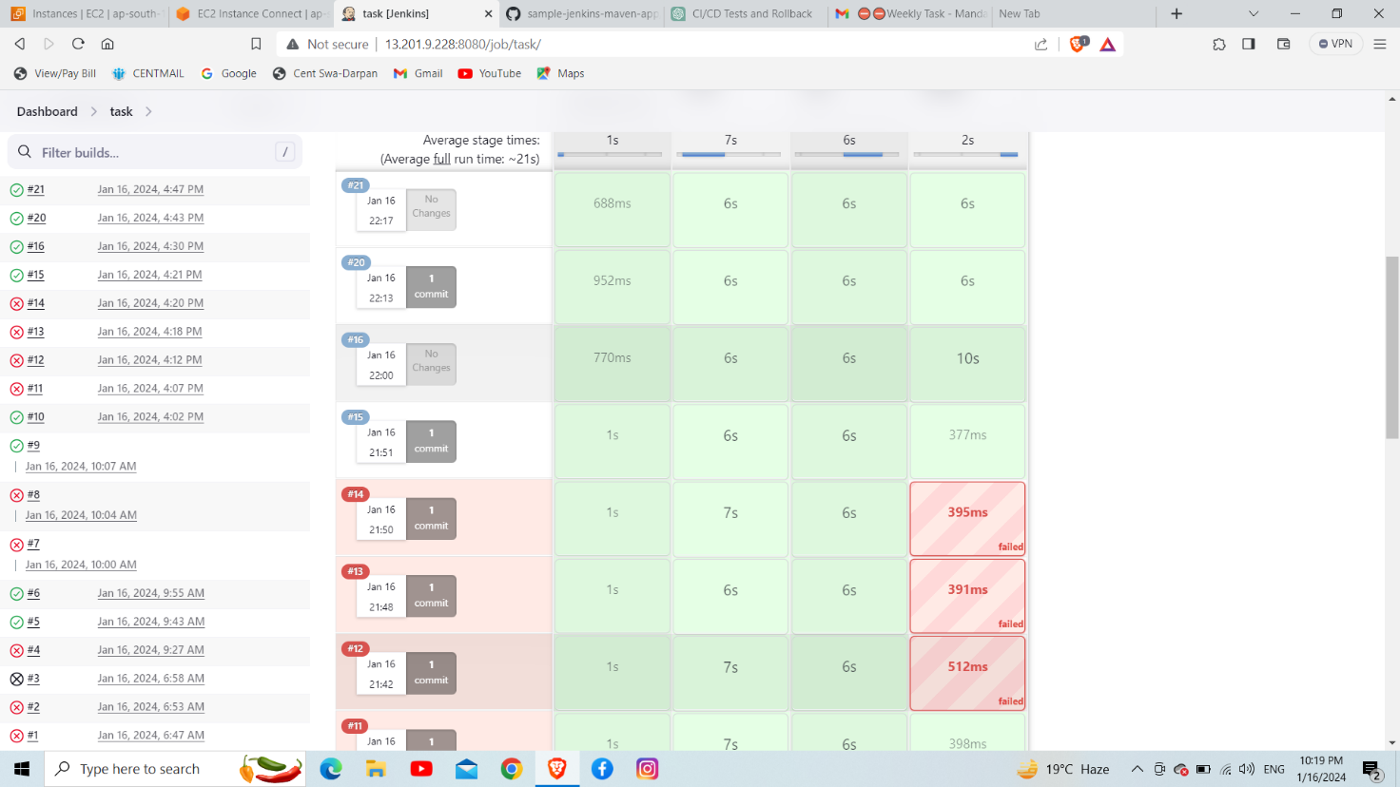

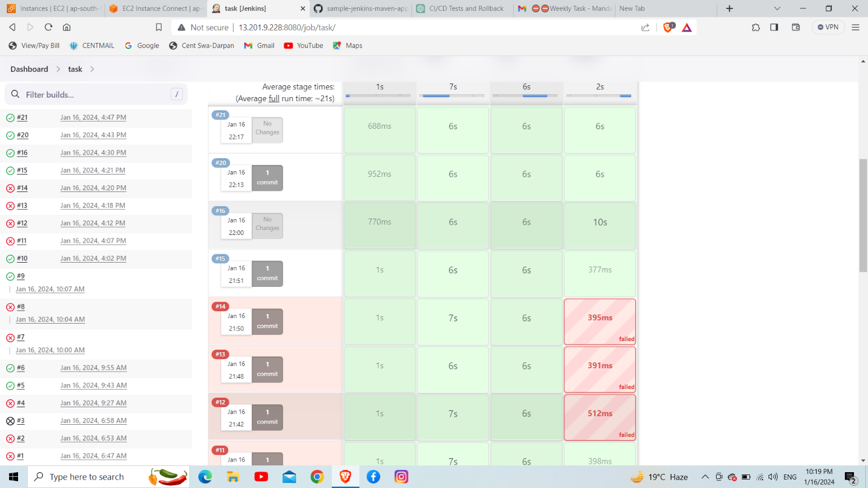

1. Second test case

